Name Date
Stage 9 End of unit 4 test
1 Solve these equations.
a 2x + 10 = −16 b 21 − 3y = 6 c 4x + 3 = 30 − 5x

[6]
2 Solve the equation 6(x − 5) = 2x + 14.

[3]
3 Show that these equations all give the same solution for y.
a b c

[6]
4 The angles of a triangle, in degrees, are 3(x + 16), 9x − 4 and 2(23 − x).
a Write down an equation for x.
[1]

b Solve your equation to find the value of x.

[3]
c Work out the sizes of the angles in the triangle.

[3]
5 Solve these simultaneous equations using an algebraic method.
y = x + 12 and y = 4x + 3

[3]
6 a Complete the tables of values for each equation.
y = 2x + 4 | x | 0 | 2 | 4 |  | y = x + 6 | x | 0 | 2 | 4
 | y |  |  |  |  |  | y
[2]
b On the graph paper draw a coordinate grid from 0 to 5 on the x-axis and from
0 to 15 on the y-axis.
Plot the points from your tables on the grid and draw the straight lines y = 2x + 4
and y = x + 6.
 [2]
c Write down the solution of the simultaneous equations y = 2x + 4 and y = x + 6.
[1]
7 Solve these simultaneous equations using an algebraic method.
a x + 6y = 15 and 5x = 2y + 11

[3]
b x + 8y = 28 and x − y = 1

[3]
8 Solve these inequalities. Show each answer on a number line.
a 6x > 12 b 5x + 3 ⩽ 18 c −12 ⩽ 4x < 8

[6]
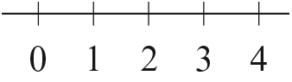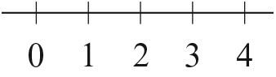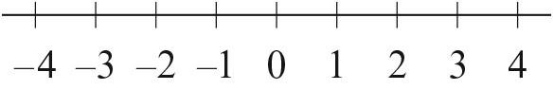
9 The diagram shows triangle EFG.
Side EG is longer than side EF.
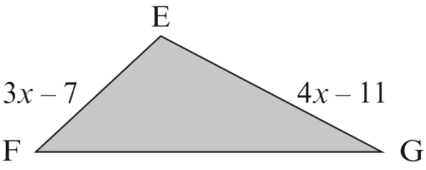
a Write an inequality to show this information.
[1]
b Solve your inequality.

[2]
[Total: 45 marks]
END OF TEST

